INFORMATION BULLETIN No.1
3rd International Dragon Boat Festival in Belgrade, Serbia 23.09.2017.

Dear Dragon Boat Friends,

The 3rd International Dragon Boat Festival will take place on

Sathurday, September 23rd 2017 at Ada Ciganlija Lake, Belgrade, Serbia.

- LOCATION: The 3rd International Dragon Boat Festival in Belgrade will be held at Ada Ciganlija Lake. The lake is located 30 min away from the Belgrade’s International Airport Nikola Tesla.
- There are several 2-4 star hotels in the surroundings, at 10 min distance.
- The lake is completely adapted for the competition. Numerous world and European championships in kayak/canoe and rowing were held there.

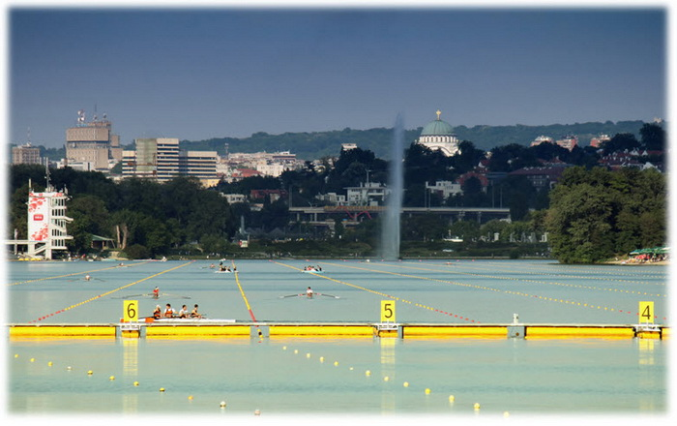
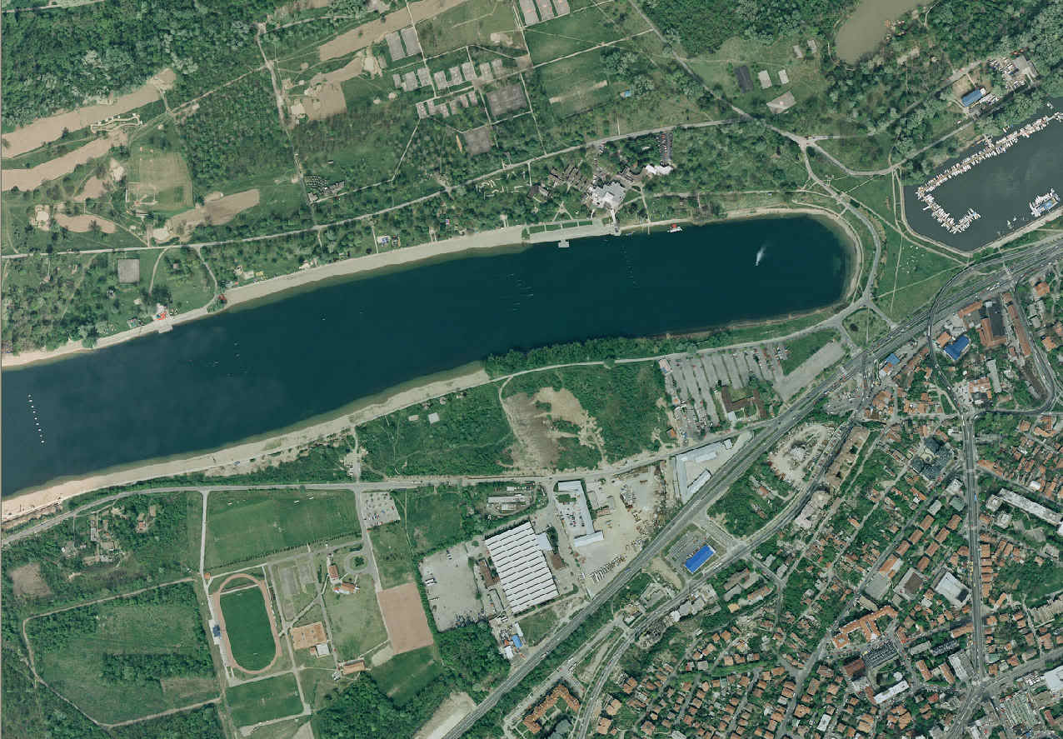

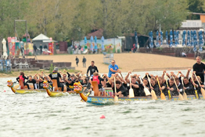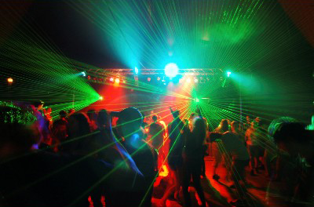
COMPETITION FORMAT:
- Sathurday, September 23rd 2017 :
500m Racing (All Crews)
200m Racing (All Crews)
- REGATTA COURSE: The Regatta Course and technical facilities will comply with EDBF standards. There will be no racing lines on course.
- BOATS AND EQUIPMENT: The Event Organisers will provide three IDBF standard racing boats (Champion manufactured).
- RULES OF RACING: The racing will be conducted under the current IDBF Racing Rules and Regulations and any conditions which are contained in this Bulletin.
- PERSONAL SAFETY: All paddlers are expected to be able to swim 50m in light clothing unaided or as a minimum be water competent in cold water. All experienced International paddlers will not be required to wear a PFA; however the SDBF will have a sufficient supply of life jackets should they be required. Crews compete entirely at their own risk and must be “Fit to Race” under the IDBF Competition Regulations.
- CATEGORIES:
  - Standard boat: Open (Mix team configuration, minimum number of paddlers = 16)
  - All women team (200m only), minimum number of paddlers = 16)
  - Small Crews (10-12 paddlers) using the Standard Boats
- INQUIRIES and REGISTRATION: dragonboatserbia@gmail.com
- DEADLINE for PROVISIONAL NUMBER REGISTRATION: 15.08.2017.
- DEADLINE for TRANSPORT REQUESTS: 01.09.2017.
- DEADLINE for FINAL NAME REGISTRATION 16.09.2017. (attached)
- PARTICIPATION FEE: €15/person
to be collected at the team manager’s meeting.
- AIRPORT TRANSFER and HOTEL VENUE TRANSFER (on 22.09. and 23.09.)
will be organized upon request, for €20/person.
- Lifeguards and doctor will be there for the safety of the participants.
- Briefing about progression system, traffic rules, etc., at team manager’s meeting.
- Sandwiches, refreshments, coffee and water will be sold at reasonable prices at the venue.
- All members of each team must wear uniform T-shirts.

TIMETABLE

Date: |  | Time:
Friday 22.09.2017. | Training session | exact time to be agreed  based on registration
Friday 22.09.2017. | Team Captain Meeting | exact time and place to be agreed
Saturday 23.09.2017. | Opening ceremony | 09:30h – 10:00h
Saturday 23.09.2017. | Race 200m and 500m | 10:00h – 16:00h
Saturday 23.09.2017. | After Party | exact time and place to be agreed based on registration

- FREETIME Please visit web page for information http://www.tob.rs/
PROVISIONAL ENTRY FORM
Please submit latest till 15.08.2017. to dragonboatserbia@gmail.com

PROVISIONAL NUMBER ENTRY FORM
Club Crew Name
Country
Number of participants
Transfer request
Training request
Number of participants
interested for Bus Tour
Contact Name
Phone Number
E-mail Address
Mailing Address

- FINAL ENTRY FORM (excel list attached)
Please submit latest 16.09.2017. to dragonboatserbia@gmail.com

- MORE INFORMATION IN BULETTIN No. 2.

Welcome to Belgrade!

SERBIAN DRAGON BOAT FEDERATION

